

**LAB ASSIGNMENT 4**

***JAVA PROGRAMMING***

***CSC305 – PROGRAMMING PARADIGMS***

|  |  |
| --- | --- |
| **NAME** | **MUHAMMAD FAIZ BIN MOHD FAIZAL** |
| **CLASS** | **DCS 5A** |
| **LECTURER** | **PUAN KASNIAH BINTI NENI** |
| **UITM ID** | **2015411572** |

**PYQ SEPTEMBER 2013**

**PART A**

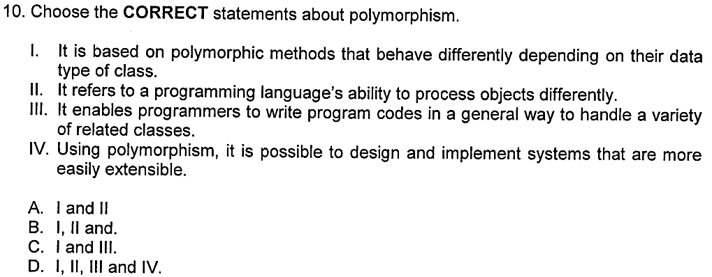

1. I and II
2. I, II and.
3. I and III
4. I, II, III and IV

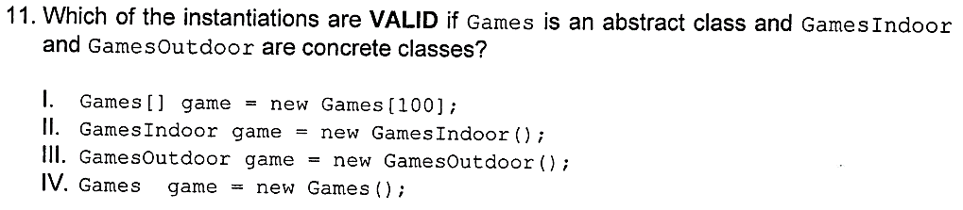

1. I and II
2. I, II and III
3. I and III
4. I, II, III and IV

**PART B**

**QUESTION 3**

**Given the following superclass and subclass:**

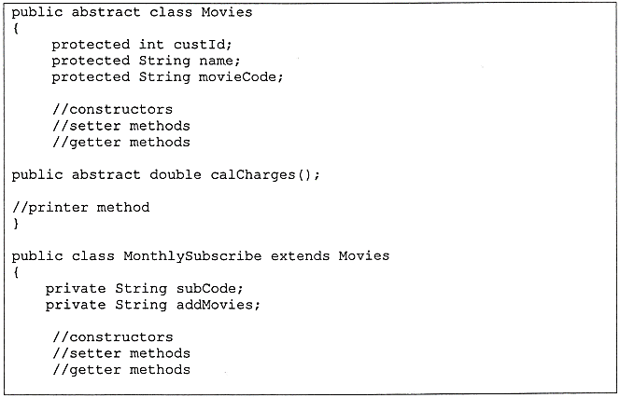

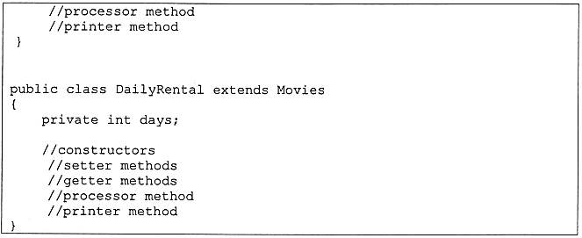

1. **Write the definition of normal construction for both subclass.**

//Class MonthlySubcribe Normal Constructor

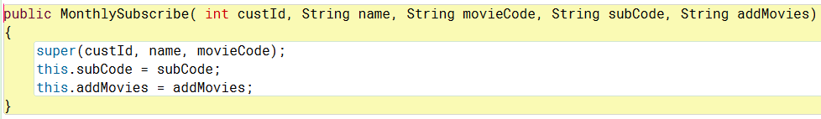

//Class DailyRental Normal Constructor

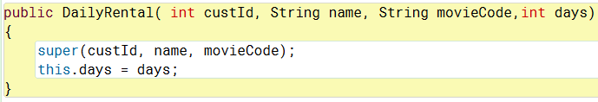

1. Write the definition method calCharges() for both subclasses. Table 1 and Table 2 are given below to help you in writing the method.

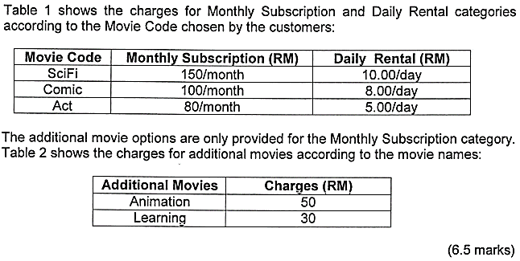

//Class MonthlySubcribe calCharges()

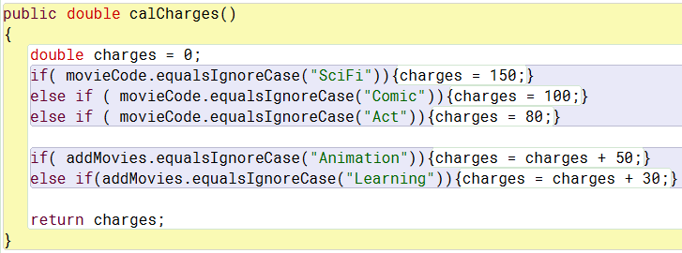

//Class DailyRental calCharges()

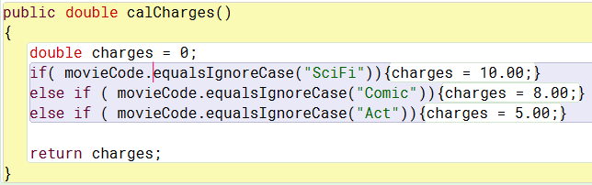

1. **Given the following array declaration in a Java application:**

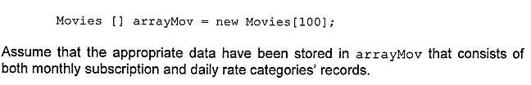

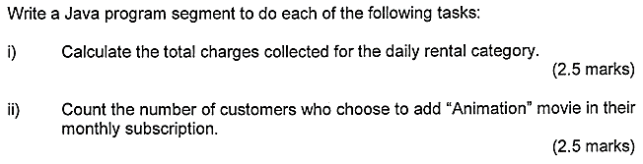

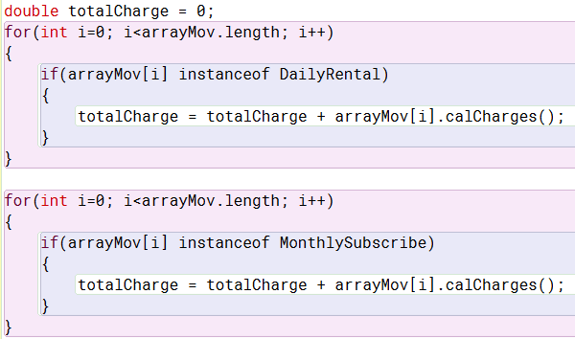



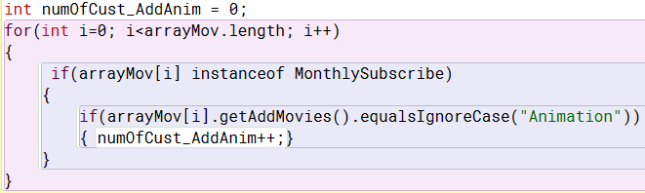

**FULL CODING**

**//Input file**

**movies.txt**



